**Appendix 1. NCI Invention Disclosure Form**

NCI INVENTION DISCLOSURE FORM

1. Title of Invention

PaperTrail – Document and Note Sharing Application

1. Inventors

|  |  |  |  |  |
| --- | --- | --- | --- | --- |
| Name | School/Research Institute | Affiliation with Institute (i.e. department, student, staff, visitor) | Address, contact phone no., e-mail | % Contribution to the Invention |
| Fouad Animashaun | National College of Ireland | Student | 40 Castlegrange Avenue, Swords, Co.Dublin, 0872732800,  ayofouad@gmail.com | 25% |
| Robert Brown | National College of Ireland | Student | Yuzhangchen0714@gmail.com,  0894653260,  3 yellow meadows lawn,  Clondalkin,  D22 | 25% |
| Yuzchang Chen | National College of Ireland | Student | [robert97brown@gmail.com](mailto:robert97brown@gmail.com), `  +353 87 905 866715, eastham cove, bettystown co.Meath | 25% |
| ,Lorcan Bowes | National College of Ireland | Student | Lorcanb17@hotmail.com  0861680676  Blacklion Stores, Balrath  Navan  Co. Meath | 25% |

1. Contribution to the Invention

Each contributor/potential inventor should write a paragraph relating to his/her contribution and include a signature and date at the end of the paragraph.

Fouad Animashaun – File Upload system: When a user uploads a file, they are able to give the file a name and a short description. This data is then send to the database and the uploaded file is save to a file on the server. The uploaded file is pulled from the database using arbor.js and is displayed to the user in the form of a node/circle on the screen. When a node is click a review, the system will appear on the screen asking the user to review the uploaded material. Graph Visualization: All the graph components are rendered using Arbor.js and data is pull from the database when data is being rendered PHP is pulling data from the database to fill in the necessary parameters that arbor.js need to render the graph.

Lorcan Bowens – Registration System: When a user inputs their information into the signup form, the data delivered is taken and stored in our database. This action is completed using a POST method in PHP. Here PHP variables are created in order to hold the information gathered by the user. ‘If statements’ are then run to handle errors. Following this, an SQL insert transaction is executed, which stores the user’s successfully inputted information. Prepared statements have also been employed to combat SQL injection.

When an INSERT is made, placeholders are used in place of the information given by the user. The code is then parsed inside the database. Now the placeholders are replaced with the users given information, however this code is sent using a different protocol and is not actually read as code within the database, but rather characters. Furthermore, the default hashing algorithm (PASSWORD_DEFAULT) included in PHP, currently exercising ‘bcrypt’, was used to hash users’ passwords to tighten security. PhpMyAdmin was the administration tool used to monitor the database.

Chatroom: The chatroom was built using the same principals discussed above. A variable was assigned to the corresponding message field in a form that includes a POST method to the PHP page. Ajax was implemented to include live refreshing to ensure the message history in the chatroom room remains updated.

YuZhang Chen – Rating system: when a user rates a note or multiple notes, the data is collected and sent to the database using the PHP POST method. This rating is stored in the database as a composite key meaning that the rating_Id, user_Id(FK), and note_Id(FK) are all primary keys. This is inserted into the database with a SQL insert statement.

1. Description of Invention

(Please highlight the novelty/patentable aspect. Attach extra sheets if necessary including diagrams where appropriate). What is novel, the ‘inventive step’? For more information on patents, please look at <http://www.patentsoffice.ie/en/patents.aspx>

Our application will allow users to access an abundance of study material used by their peers for a variety of different subjects. The system works as follows:

A user selects a subject from the *library* and is taken to a ‘*subject canvas*’. All uploaded material and its feedback are visually represented on a network graph. Uploaded material is represented as a *circle node* on the network and individual user’s comments and reviews will be represented as a *square*. Nodes and user reviews will be connected via *edges* (straight lines) which are altered based on users reviews i.e. its color and thickness.

Users can hover over *edges* to read user’s comments and opinions. Once a user downloads the document, they will be given the opportunity to post a *review* and comment on that material. Our review system offers 3 options: Perfect, Relevant, Irrelevant. These options will alter the edges characteristics.

Users will also be given the option to upload their own material, this can be done within the subject’s canvas.  A user simply attaches their document and fills out some descriptive details.

This method of visually representing the materials will help users quickly determine which notes are worth using and downloading.

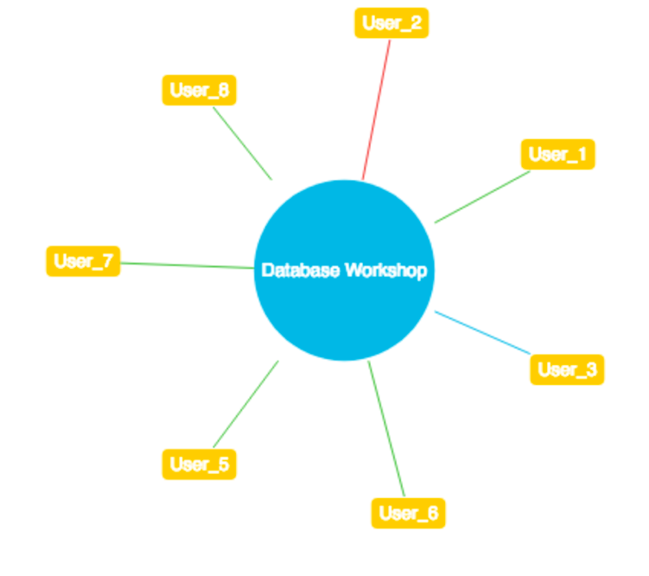

1. Why is this invention more advantageous than present technology?

What is its novel or unusual features? What problems does it solve? What are the problems associated with these technologies, products or processes? Explain how this invention overcomes these problems (*i.e*. what are its advantages).

The unique selling point of Papertrail is the ability for students to share notes among one another in an informative, simplistic and accessible way as possible. Papertrail does this using graph visualization to represent the quality of the uploaded or shared material. The quality of note is determined by the students who have accessed and evaluated the material making the product 100% student operated. This method of visually displaying the community’s opinion will speed up the process of deciding what material is relevant.

We have studied multiple note sharing websites, these websites uploaded material is in the form of a static mundane list and these sites do not grant user the ability to share notes with everyone within their class but instead they only provide the ability for notes to be shared with specific people. These sites don’t not allow for community opinion in a visual way. Papertrail allows users to determine within seconds the beneficial of the uploaded material and notes can be shared instantaneously amongst class mates.

1. What is the current stage of development / testing of the invention?

**Completed:**

**Accounts Set Up -** Users can create an account which is necessary to review materials.

**Log In -** Users can access their account by signing in with their username and password

**Upload functionality -** Users can select local files on their machine and upload them to the application.

**Download functionality -** Users can download any uploaded material form the application.

**Graph-node generation -** When a file is uploaded, it appears on the dash board as a node.

**Dynamic dashboard** – When another subject is chosen the same dashboard is rendered.

**Remaining:**

**Reviewing System** - The review system is currently being developed to help students distinguish irrelevant notes from relevant notes.

**Chatroom** – A Chatroom is being developed to help users request material that may need to be uploaded and students may have discussions about anything college related.

1. List the names of companies which you think would be interested in using, developing or marketing this invention

**Moodle** – Moodle currently only allows for lectures to upload notes to the students in their class but does not provide a hub for students to share notes amongst each other. We believe that Moodle would be interested in this product as it would provide value to those in education.

**National College of Ireland** – We believe that the national college of Ireland may benefit from this product in that it will provide brand new method of studying for students and improve student engagement.

**Udemy** – Since Udemy has multiple courses with its own community we believe that by improving student engagement and collaboration students will gain much more of an understanding from one another sharing study notes on topics that other might not understand very well.

1. Funding Partner(s)



National College of Ireland

Government Agency & Department

10%

%

* Support Contract/Grant No. Contact Name Phone No. Address

MP 289364

%

+353 20 915 8146

James Park

%



Industry or other Sponsor

Education

%

* Support Contract/Grant No. Contact Name Phone No. Address

KP 289364

%

Michael Parker

%

+353 20 917 7892

5%

%

1. Where was the research carried out?

The research was carried out at the National College of Ireland where we interviewed multiple students in our class asking them what they would like in a note sharing system and what benefits would this system have on their lives and their study.

1. What is the potential commercial application of this invention?

The commercial application of this invention is a student subscription. We intend to have a download limit of 3 notes after then the student will be prompted to pay a monthly subscription for Papertrail. We are planning to develop a version of Papertrail that is accessible to all colleges but will cost a yearly fee.

1. Was there transfer of any materials/information to or from other institutions regarding this invention?

If so please give details and provide signed agreements where relevant.

No.

1. Have any third parties any rights to this invention?

If yes, give names and addresses and a brief explanation of involvement.

No.

1. Are there any existing or planned disclosures regarding this invention? Please give details.

We intend disclose this information to the national college of Ireland, as we believe that the college may interested in a project that intends to aid students in their university endeavours.

1. Has any patent application been made? Yes/No

If yes, give date: Application No.:

Name of patent agent:

Please supply copy of specification.

1. Is a model or prototype available? Has the invention been demonstrated practically?

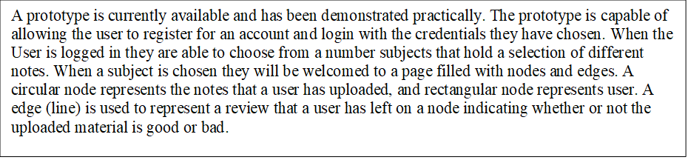

# I/we acknowledge that I/we have read, understood and agree with this form and the Institute’s *Intellectual Property and Procedures* and that all the information provided in this disclosure is complete and correct.

**I/we shall take all reasonable precautions to protect the integrity and confidentiality of the IP in question.**

|  |  |  |
| --- | --- | --- |
| Inventor: | Fouad Animashaun | Signature Date: 23/11/18 |
| Inventor: | Robert Brown | Signature Date: 23/11/18 |
| Inventor: | Yuzhang Chen | Signature Date: 23/11/18 |
| Inventor: | Lorcan Bowes | Signature Date: 23/11/18 |